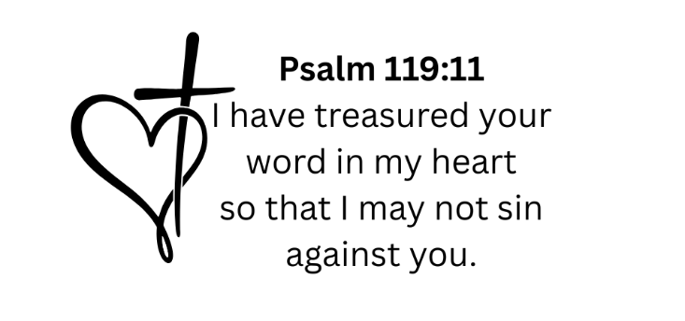

__________ Scripture to Memorize:
________________________________________________________________________________________________________________________________________________________________________________________________________________________________________________________________________________________________________________________________________________________________________________________________________________________________________________________________________________________________________________

____________ Scripture to Memorize:
_____________________________________________________________________________________________________________________________________________________________________________________________________________________________________________________________________________________________________________________________________________________________________________________________________________________________________________________________________________________________________________

____________ Scripture to Memorize:
________________________________________________________________________________________________________________________________________________________________________________________________________________________________________________________________________________________________________________________________________________________________________________________________________________________________________________________________________________________________________________

