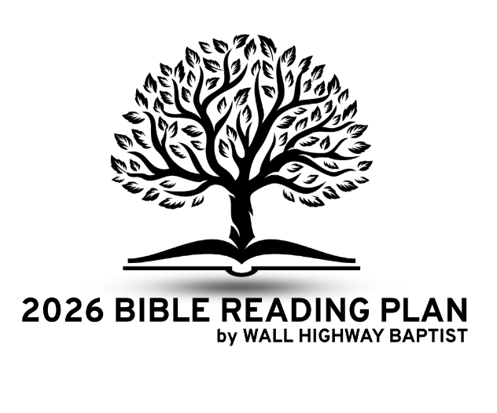
Letter Overview: _______________
Who?
- Author: _____________
- Audience: _____________
When?
- Time period written: ____________
- Historical context:
___________________________________________________________________________________________________________________________________________________________________________
Where?
- Facts/Characteristics about where the audience lived: __________________________________________________________________________________________________________________
- Paul’s circumstances when writing the letter:
__________________________________________________________________________________________________________________
What?
- Themes of the letter: ____________________________________________________________________________________________________________________________________________________________________________________________________________________________________
Why?
- Paul’s purpose(s) for writing the letter:
__________________________________________________________________________________________________________________
How?
- What practical applications are highlighted?
___________________________________________________________________________________________________________________________________________________________________________
More Notes (outline, major sections, points of interest, other notes):
__________________________________________________________________________________________________________________________________________________________________________________________
__________________________________________________________________________________________________________________________________________________________________________________________
__________________________________________________________________________________________________________________________________________________________________________________________
__________________________________________________________________________________________________________________________________________________________________________________________
__________________________________________________________________________________________________________________________________________________________________________________________
__________________________________________________________________________________________________________________________________________________________________________________________
__________________________________________________________________________________________________________________________________________________________________________________________
__________________________________________________________________________________________________________________________________________________________________________________________

